“How Many Sq. Ft. You Can Buy with $500K”.

The three major issues that I am focusing on are overuse of color for data representation, ineffective use of space and layout, and a lack of trend information or context. I have attached my rendered Tableau graphs to the assignment as a PDF for increased clarity.

1. Misuse of Color and Lack of Clear Data Representation

Firstly, the visualization heavily relies on various shades of pink to represent different price ranges, which creates several problems that compromise its effectiveness. This approach violates Tufte's principle of effective comparison by making it difficult to distinguish the exact differences between states (Tufte, 1997). The color gradations are too subtle, especially for adjacent price ranges, making it difficult for the audience to quickly understand the data and draw meaningful comparisons. Moreover, the use of color as the primary method for data representation does not embody Tufte's multivariate principle (Tufte, 1990). While the size of each state's square varies to display extra information, the relationship between size and color is not immediately clear, which is confusing to viewers and ultimately obscures the underlying data patterns.

To improve this visualization for this aspect of design, I would use a more distinct color palette with clearer differentiation between price ranges. A choropleth map with a well-defined legend that clearly associates each color with its corresponding price range would help the visualization's readability and interpretation. This approach would better embody Tufte's principles of comparison and multivariate representation, allowing viewers to compare states and understand the data's complexity more easily (Tufte, 1997). I would still add the numerical values within each state's area, as it provides more precise information, fulfilling Tufte's documentation principle (Tufte, 1983). This addition would bypass the need for viewers to estimate values based on color alone, improving the chart's accuracy and usefulness. By combining color coding with explicit numerical data, the visualization would offer both an immediate visual overview and detailed information for those who want to delve deeper. Going back to changing the color scheme; I would use a diverging color scheme centered around a meaningful midpoint (for example, the national average square footage purchasable with $500K). This would not only make it easier to identify states above and below the average but also highlight the degree of deviation from the center. This would overall enhance the visualization's ability to tell a story about housing affordability across the United States, making it engaging and informative for viewers (Tufte, 1990).

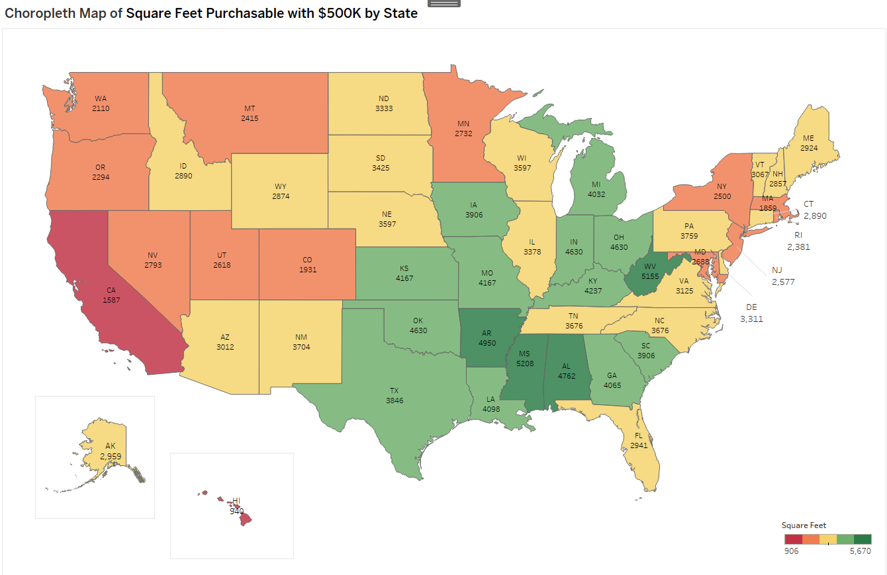

2. Ineffective Use of Space and Layout

The current layout of the visualization, while attempting to maintain some level of geographical accuracy, results in a lot of wasted space and weakens the ability to make quick and accurate comparisons between states. This issue contradicts Tufte's principle of integration, as it fails to effectively combine geographical context with the primary data (Tufte, 1990). The varying sizes of state squares, which are meant to represent the total amount of square footage that $500K can buy, creates an inconsistent visual scale that can lead to further misinterpretation. States with similar values but different physical sizes (such as California versus Rhode Island) are difficult to compare at a glance, compromising the chart's purpose of displaying state-to-state comparisons. Furthermore, the grid-like arrangement distorts the actual spatial relationships between states, which is misleading to viewers that are not familiar with American geography. This distortion not only affects the readability of the data but also potentially introduces bias in interpretation, as viewers might incorrectly assume geographical proximity or regional similarities based on the grid layout (Tufte, 1983).

To address these issues, I would redesign the visualization as a sorted bar chart. A bar chart would allow for easy comparison of values across all states, fitting more closely to Tufte's comparison principle (Tufte, 1997). It would enable viewers to quickly rank states from highest to lowest square footage and notice any large gaps or clusters within the data. This format would eliminate the spatial distortions present in the current design and provide a clear representation of the data while allowing for accurate comparisons. To maintain geographical context without compromising any data clarity, I would include a small reference map alongside the primary visualization. This chart would be the same chart that I explain in the first section and would serve to complement the detailed state-by-state data in the main chart. This approach of using multiple charts would be better to integrate various modes of information as Tufte suggests, while still prioritizing the clarity of the data itself (Tufte, 1990). The combination of a sorted bar chart with a geographic reference creates a good balance between data accuracy and spatial context, allowing viewers to understand both the fiscal differences between states and any regional patterns that might be uncovered.

3. Lack of Context or Trend Information

After thoroughly analyzing the visualization, it becomes clear that only a static snapshot of housing prices across states is provided. This means there is no temporal context or trend information. This contradicts Tufte's principles of causality and context (Tufte, 1997), leaving viewers without insight into how these figures have changed over time or what factors might be influencing the current values. Without this broader perspective, visualization limits its ability to tell a comprehensive story about the housing market and is unable to provide viewers with the tools to understand future trends or make any informed decisions. The lack of historical context makes it impossible to determine whether a state's position represents a long-term condition or a recent shift, offering no insight into market dynamics that multiple data points could provide (Tufte, 1983).

To improve the visualization's informational value, I would incorporate trend lines or small multiple charts for each state, showing how the square footage purchasable with $500K has changed over recent years. This addition would address Tufte's context principle by showing the before and after for each state, hinting at future trends (Tufte, 1990). I would also include relevant economic indicators (such as median income, population growth, or job market data) as secondary visualizations to provide additional context for interpreting the primary data. This approach would satisfy Tufte's causality principle by suggesting potential reasons for the price variations across states (Tufte, 1997). For example, a scatter plot comparing square footage to median income could reveal whether housing affordability relates to economic conditions. I would also add some textual context which would highlight the main findings or conclusions from the data (for example, why Washington D.C. has high prices compared to neighboring states). This would integrate different modes of information, improving the overall effectiveness of the visualization (Tufte, 1990). Small annotations or callouts for notable outliers or interesting data points could also be added as needed, providing quick insights that invite further 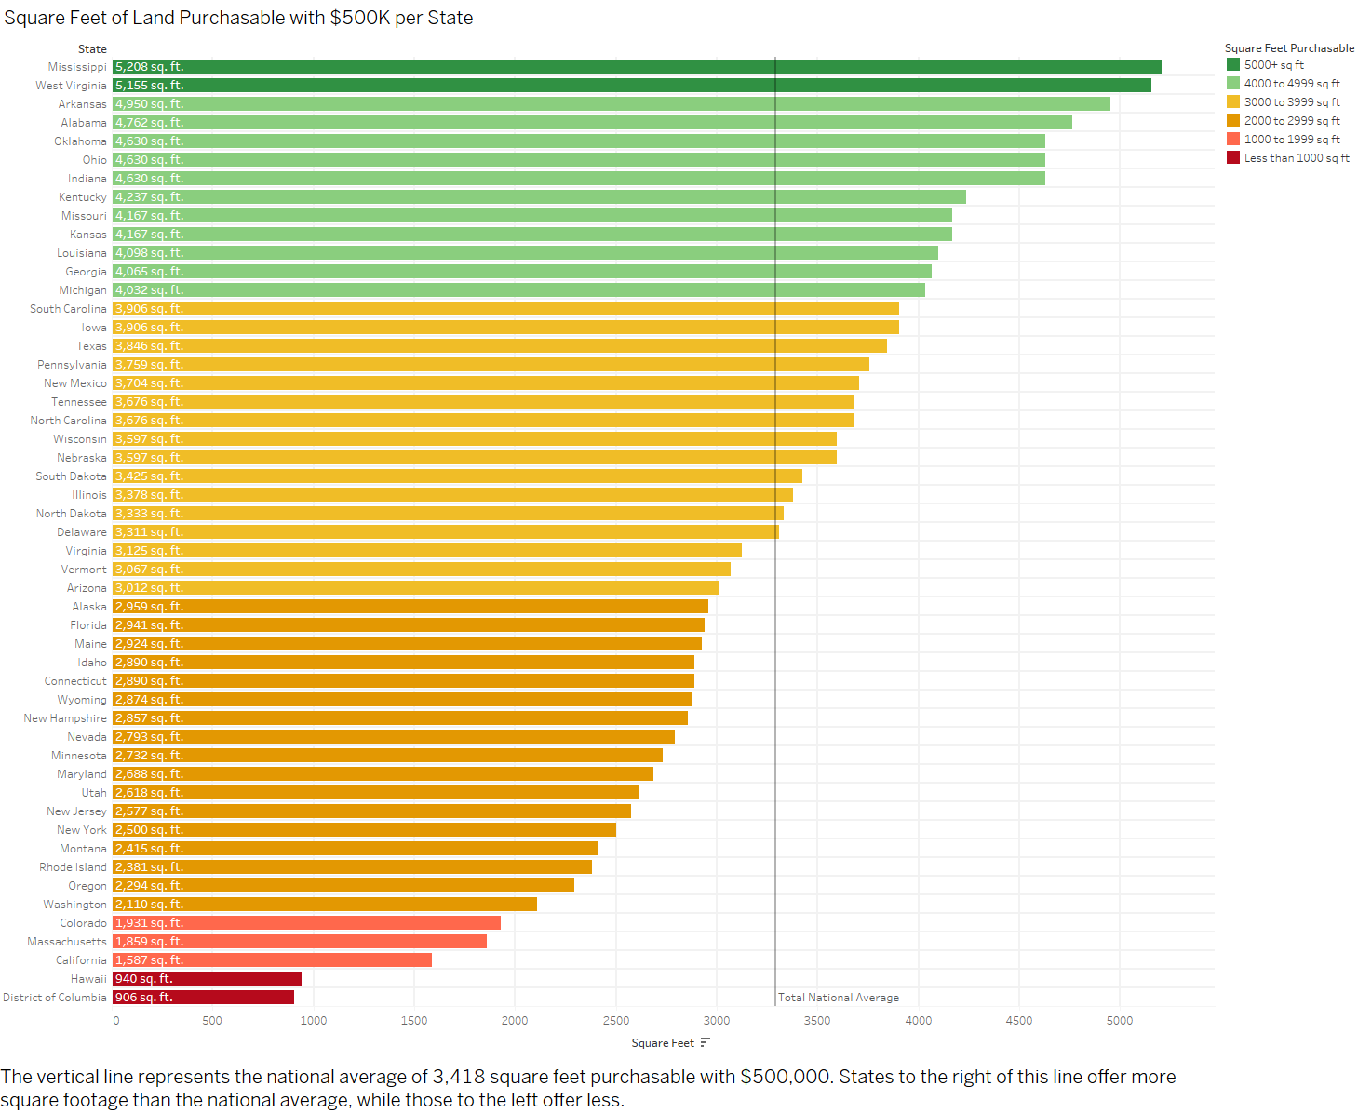exploration.

**References**

Tufte, E. R. (1983). The visual display of quantitative information. Graphics Press.

Tufte, E. R. (1990). Envisioning information. Graphics Press.

Tufte, E. R. (1997). Visual explanations: Images and quantities, evidence and narrative. Graphics Press.

*Visualizing How Much Home $500K Buys You in Every State*. (n.d.). HowMuch. Retrieved July 1, 2024, from https://howmuch.net/articles/how-many-sqft-you-can-buy-500k